Synamedia MEG IRD - How To Turn LNB Voltage

**Task-** Configuring MEG IRD

**Condition-** Turning DC Voltage on to power LNB

**Standard-** How to activate IRD DC Voltage for MEG IRD

* + Begin by **Browsing to IP** of MEG IRD (Default ip - 192.168.2.20)
    - **Enter UN & PW** *(see figure 1) (UN: Admin ; PW: Password)*

*Figure-1*

* Navigate to Advanced View by clicking 3 lines in upper left corner
  + Expand I/O on the left (input) section
  + You should now see DVBS2 1
    - Right Click on DVBS2 1
    - Click on configuration (see figure-2)

Figure-2

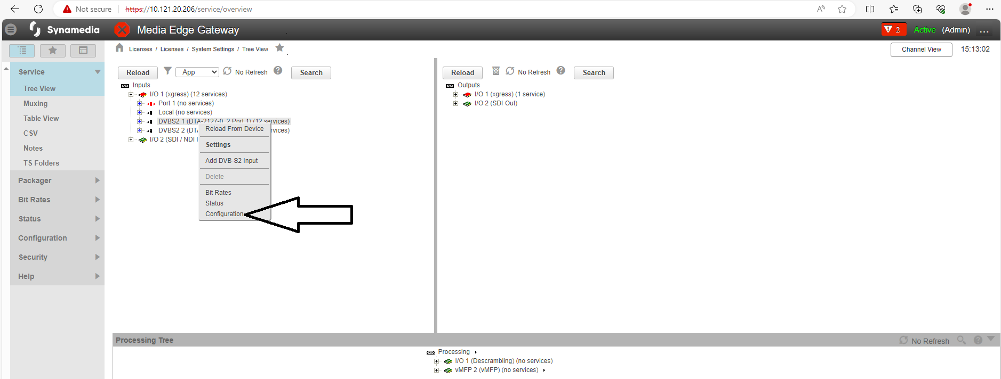

* You should now see the PCI card configuration
* Scroll to the bottom of the page and locate DVB-S2 Port Setting
  + Next, click the dropdown under LNB Settings / Polarization (see figure-3)
    - Choose Horizontal
    - Navigate back to the top of the page and hit Apply
* LNB Voltage is now active

Figure-3

